

**COMP 8851 Major Project internship (part-time)**

**Final Report**

ITIC - Systems, Education and Research

Parth Patel (45862699)

Student Email: parthkanubhai.patel@students.mq.edu.au

Session-2

Submission Date: 07/11/2021

Department of computing

Faculty of science and engineering

Sydney, Australia

# Acknowledgement:

This report would not have been possible without the help of my mentors, faculties and my friends. I especially wants to thank you to my faculty **Dr. Amin Beheshti** who have guided me through all of our documentation process and report format and how to do well in out internship journey. In the end it is a new experience for me. And how to put use in that knowledge in future to get better job and to be a better person as whole.

I am grateful to all of those with whom I have had the pleasure to work during this and other related projects. I am still doing my project work but my learning mentor **Ava Assadi** from ITIC organization has taught me a great deal about the basics and advanced level of Data Science skills one would need. And my project mentor deserved the credit more than he ask for and his name is **Ivan Bakshayeshi** who have guided us through our project work by arranging weekly meetings giving us the brief about what to do next and solving our problems individually if we have any.

Nobody has been more important to me in the pursuit of this project than the members of my family. I would like to thank my parents, whose love and guidance are with me in whatever I pursue. They are the ultimate role models. And it is my pleasure to have all these people I have mentioned above in my life and for them to be part of this with me on this amazing journey. And lastly I would like to thank to the **Macquarie University** for allowing me to have this amazing internship experience through their **Data science** coursework

# Executive summary:

Summary represent the overview of this report. This report is mid-term report which consists my learning experience form week 1 to week 6 at organization called ITIC systems and research Pty Ltd. It includes my learning and starting my hands-on work experience project journey.

Reports starts as describing a little bit about ITIC’s history what company does, their competitors, the hierarchy structure of the organization, Partners etc. Then I have write down a in-depth about my internship program and what it offers. And the time frame in which it will be completed.

Then I have written about my mentors related to the program. which is Ava Assadi who is my learning phase mentor, and then Ivan Bakhshayeshi who will guide me through my hands-on work experience phase where I have selected project regarding Smart students attendance system. All the detail description about the project is mentioned.

The report include my journey through all the six weeks, my challenges, knowledge gained and tasks achieved all of the are mentioned in depth. It also mention my suggestion and difficulties which I have faced during those period.

And in the last but not least I have carried out some critical analysis in which I have faced problems or difficulties putting out my knowledge to test in the organization, I have also written about strengths and weaknesses about the organization and how It can be improved In the suggestions tab which in terms helps the organization.

Table of Contents

Acknowledgement: 2

Executive summary: 3

Overview of the organization: 5

Organizational Structure: 6

Plan of internship program: 7

Training Program: 8

Fig-1 9

Reflective Journal Entries: 10

Work samples: 16

Sample 1: 16

Sample 2: 16

Sample 3: 17

Sample 4: 18

Sample 5: 18

Critical Analysis: 20

SWOT Analysis: 21

Conclusion: 22

Recommendation: 23

References and sources: 24

# Overview of the organization:

ITIC is a system, Education and Research support and services centre based in Sydney, NSW. It was established in 2001. It is a IT training, support and project implementation provider throughout Australia and New Zealand.

It Provides internship opportunities in subjects like Data Science, Cyber Security, IT helpdesk, Networking, Software and guidance in career planning in their ITIC live program. It also provides space for exams like Pearson, PSI, Kryterion and prometric etc. it offers courses for you to study like data science, CISCO, Microsoft etc. ITIC has been partnered with some of the best NSW universities and provide toolkit for the students to get familiarize about the work place to real world.

They also frequently organize seminars and hackathon with having partnership with universities like Macquarie, UTS and UNSW etc. especially with the Macquarie with the AI enabled hackathons and its AI enabled education programme which includes several streams like AI-enabled policing, banking, education and AI-enabled industry. Which is supported by their partnership with Australian Federal Police (AFP), TATA consultancy services (TCS), ITIC and Fathem.

There are also competitors for the ITIC as well in the market and according to zoom-info they are university of riverside, capital training institute, phoenix TS, Steepletown neighbourhood services etc.

# Organizational Structure:

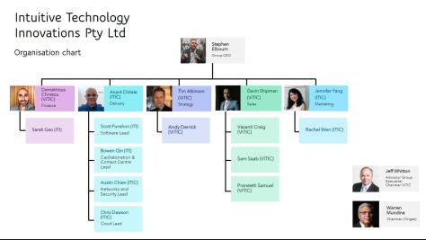

ITIC main office is located in the heart of Syndey CBD on the pitt street, as you can see in the organization’s hierarchy chart group. Stephen Elbourn is the CEO of Intuitive technology innovations Pty Ltd. Below him there are various departments and their heads are listed. ITIC is one of the company which is part of the group, it has around 11-50 employees according to linked In profile of the company.

There are several other companies which are the part of the ITI group and they are ITIC, ViTIC, Yirigaa, Yarnlab etc. ITIC consists of several departments like finance, delivery, strategy, sales and marketing etc. and their representative are shown above in the picture.

Recently ITIC has partnered with indigeneous technology company yirigaa and his chairman is Mr Warren Mundine. It basically provide skills to engineers to work in the CSOC and NOC located in Orange, NSW. Telstra comms recording predict is delivered and supported by ITIC. The incoming yirigaa engineers will be trained on this product to provide service to Telstra and its client across Australia.

# Plan of internship program:

As opposed to the traditional internship program held in a company, this year due to covid-19 pandemic situation all the training and classes were held and attended online from home. It has its own benefits and disadvantages too. So, there were no particular place where the internship was held.

My internship had started from 26th July 2021 to 5th Nov 2021. The program which I am enrolled in is a data science internship and it is part-time internship.

Mainly internship is divided into two parts from mid semester break, first half taught me about basic and advanced skill and knowledge required for data analyst, and all the information was provided to me by my mentor Ava Assadi. Second half of the internship started at 30th august which is set to finish around 5th November, is a hands on skill experience where I put my knowledge and skills to the test, and that part is mentored by Ivan Bakhshayeshi. The project I have chosen to do is called smart student attendance system more in detail about that in next part of the report.

# Training Program:

As I have mentioned above first half (week 1 to week 6) were my training program, which is set to be a preparation period for my project endeavour. And this half Is covered by my mentor Ava Assadi.

The course Is designed to prepare us for the basic data analytics tools and coding used by data scientist in the execution of data analytics and solving real world problems mainly it consists of six modules, one for each week of my first half and they are as below:

Python

Power BI

Tableau

SQL

Deep learning and

Machine learning

The topics which are covered was data types, functions, libraries, neural networks, deep networks, classification and various algorithms.

**Project Introduction:**

As a part of my internship program there were two projects to choose form and they were as below

* Smart student attendance system
* Auto exam marking

Each one of the project is lead by different mentor. I have opted for smart student attendance system. Because it solve computer problems by using artificial intelligence.

**Overview of the project:**

So, smart student attendance system project is lead by my mentor Ivan Bakhshayeshi. This project targets the problems which are faced and talked about many in current state. Face recognition is common for a human to identify but for the machine it is a whole other concepts. For machine it is a matrix of a thousand pixels and to learn form the pixels and identify what each one of them represent is a hard task, and that is why it is a subdivisional problem of visual pattern recognition and it would be solved by with the power of AI.

**Outcome of the project:**

Aim of the project is to successfully recognize student in an online exam and can track student’s class attendance. Nowadays due to covid-19 pandemic interaction between student and teacher is almost non-existent and very less interactive. So when student desired to skip the class and try to deceive the teacher in order to get a free attendance for the class, this system would not let them do it. It will recognize student face with its stored database match with student respective id and fill the attendance and store it in an excel sheet with having all the respective details of the student.

## Fig-1

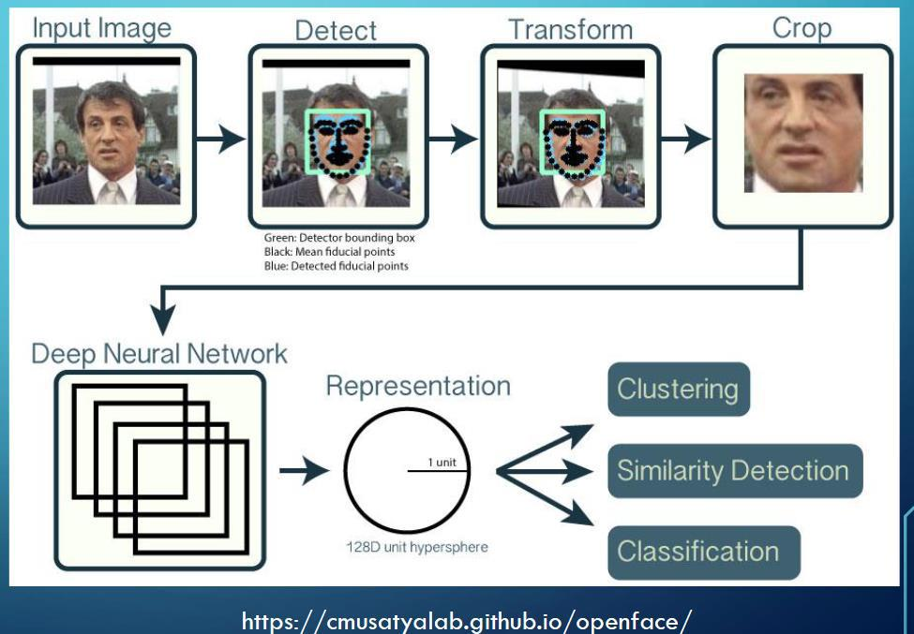

# Reflective Journal Entries:

Journal entries are basically all the activities which are carried out by me on weekly basis from week 1 to week 6, it includes all the important happening of that particular week. It shows my feeling, opinions and all the tasks are assigned to me and reflection towards the organization and the staff. For these journal entries I have used DIEP approach which is abbreviation of describe, interpret, evaluate and plan.

**Week 1(July 26 2021 – august 1 2021)**

Induction week:

First week of the internship was excited and at the same time daunting for me too cause I have no idea what to exepect from the people how they will treat me and how will be my peers to me. But as the Microsoft team meeting progress online on the first day, I have got a chance to talk to some of the department’s heads and to talk about how to succeed in the data science career what to be get prepare for. There were short introduction about the company ITIC and their heads representative. Then I had introduced to my mentors for the data science internship Ava Assadi and for my training part of the program called data analytics tools. A brief introduction about what to expect from the project.

After finishing orientation on first day, on my second day they have send me my login credentials on mail and how to login on to their learning portal. Ava was extremely helpful and professional about the whole process to me. She then gave us a brief introduction to our online course learning toolkit. First thing for us to do is to install a python for data science project with the help of anaconda environment. Then she had introduced us about the features like data types, libraries, and functions which python has to offer.

She taught us how to use python IDE from the anaconda environment which was a not a new thing for me but she was very generous about each and every step of learning approach, I also get to use the python code environment called jupyter notebook. It is very easy to use. It is the platform where person can easily code and see real time output on the sample page.

There were some of the exercise on jupyter notebook which had consisted using of pandas and numpy libraries and those libraries are very useful for data processing. All this was a little challenging from cause I have not expected to learn or to grasp this much information in short period of time, let alone in an online environment. But overall experience of the first week was cheerful.

**Week 2 (august 2 2021 – august 8 2021)**

Learning SQL:

Thiss week is assigned for a whole new task and for something new to learn. And it was SQL also known as structure query language, it is specifically used in programming language for managing data held in a relational database management system. Ava had remarkably sorted out stuff for us which makes the learning process easier for us there were range of aspects included in SQL learning which are introduction to database, ranges, sorting, grouping, string patterns, functions, use of multiple tables and accessing database using python. As a part of work examples we had created an instance on the cloud which was a relational database. And then using basic commands like creating a table, selections, removing and dropping items from the table etc.

This knowledge has given me two insights about SQL first understatnding the concept of cloud data base managements system, how to create one by myself and why it is more secure and safe to store our data on a cloud based architecture. There are several relational database provider out there like IBM Db2, PostgreSQL, oracle and amazon relational database etc.

As opposed to the other students in my class I was not having a hard time understanding and working on a cloud system cause I have worked in a similar kind of workforce before. So I was helping other sorting out their problems. Overall, It was a fun experience.

**Week 3 (august 9 2021 – august 15 2021)**

Machine learning Algorithms:

I vividly remember this week because I was late at attending my first day of that teaching week of my online class but ava was so nice to me and repeated all the parts that were already discussed to other students. This week was a design to learn what is machine learning and why it is important in using for data analysis. So for what I have understood was there are various machine learning algorithms and they are used in different situations, basically there are two programming learning one is traditional learning and second is machine learning. And this learning is for a computer to identify particular task and to repeat it over and over again to gain maximum efficiency in completion of the task. There was also a concept of data mining was introduced. It is basically deriving new knowledge from the large datasets. There are mainly three components included in machine learning and they are representation, evaluation and optimization.

So far we have gained all the theoratical knowledge about the machine learning now it is time to put it in practice so I have implemented various machine learning algorithms in jupyter notebook. The algorithms which I have implemented was k-nearest neighbour, support vector machine, logistics and linear regression, also it had teach me types of error in evaluation process for all the different algorithms.

This week was a fairly difficult to me to understand and evaluate all the machine learning algorithms and also I remember going through some personal problems, so it was hard to focus on the study but it was all rewarding experience in the end.

**Week 4 (august 16 2021- august 22 2021)**

Deep learning:

I have few assignments due on this week so this was a little challenging week for me, it was not just the new knowledge but now I have to put it in practice immediately just so that I don’t forget it. This part of the week I was introduced to deep learning and artificial intelligence which is a major part of my hands on work experience project later in 7th week of my internship, so far I have learned was that deep learning is a higher level of machine learning models. It is not just the feature extraction and classification that sets aparts the deep learning from machine learning it is also includes part of neural networks and that was particularly hard for me to understand.

Its time to put the knowledge in practice, so I have used google collab for deep learning computation, because our normal pcs can not produced that much computational power. There are various algorithms and methods. Also learned with deep learning and there are deep neural networks, descent optimization methods, ballpropagation algorithm and last but not the least convolution neural networks.

Hardest part for me to is to learn about various types of neural networks like CNN for its multilayer design and its complexity for creating model for deep learning. But to cope with this situation I have started to learn from youtube and that helped me a lot. It was a great learning experience.

**Week 5 (August 30 2021- September 5 2021)**

Data Visualization using Tableau and Power BI:

As a data analyst you just don’t derive insight and knowledge about data, but to represent those insight and knowledge about data, but to represent those data to normal people who are not data scientist and make much more use of the knowledge. So, therefore my visualization journey begins as if this week’s agenda was to use visualization tools like tableau and power BI. In the week5 pdf there is a great deal of knowledge collected by our mentor ava . for example use of various chat for various situations and as far as I recall there are types of charts like heat map, pie chart, bar chart, stack bar chart, tree map, line chart and many more.

To put our theory to the test I have installed a public version of tableau software on my pc, then our mentor taught us about few things about the software and it interface and how it works. Then we have connected our data sources to the tableau. There are few compatible data sources exist with tableau for example text file, google analytics, redshift etc. and finally creating some chart on sample datasets.

In various datasets in the visualization software and to compare those drawn chart and deriving insights from them, but the studied we get guidance from my peers and mentor and ava I was able to cope with difficulty overall.

**Week 6: (august 30 2021 – September 5 2021)**

Beginning of the project:

Now, the project work has started in this week our hands-on work experience journey begins even though for unforeseen reasons I could not be able to attend this session meeting, I have mail my project mentor ivan about this issue and he was very kind and helpful to me to sort out this issue to wrote out an email to me regarding the project description and what I should be doing in order to catch up with rest of my peer members. He basically explained the goal of the project and told me to explore the OpenCV library which is helpful in solving our computer vision problems.

So far I know that student attendance online system aim to build a face recognition system for online classes and recording the student’s attendance, by exploring and searching about the library online. I came to conclusion that I need to write a script to load images and detect those images using python and for computing power I am using google collab.

So overall my experience of a project start was not so great cause I was starting late and got left behind than others and also, I was also feeling overwhelmed to understand these concepts but I catch up because of the mid semester break and now I am back on track to completing my internship journey and this is just the half part.

**Week 7: (September 6 2021 – September 12 2021)**

OpenCv library Exploration:

The goal for this week was to look into the OpenCV library for the project's computer vision challenge. We were also instructed to conduct research into methods for reading photos and detecting faces using the OpenCV package for this assignment. In order to edit images, I was able to read images and access specific pixels in the image. Using the OpenCV capabilities, I was also able to detect faces in the photos. When it comes to computer vision problems, the OpenCV library has a wide range of features.

On that we had a meeting with our mentor to discuss about our project progression and how much knowledge we have gained about OpenCV library and how we can implement in our project and after listening to our arguments he had suggested some of the ideas to improve efficiency In image capturing process.

Using the Opencv package, I learned how to read and edit images during the week. From the cv2 face detection module, I was able to detect faces from a picture. I have seen it operate flawlessly in recognizing faces in images with many persons in them. The most challenging aspect of this challenge was detecting faces with the cv2 module. Then next week, I was assigned the task to create my own personal dataset containing my photographs. and photos of my project peers.

**Week 8: (September 27 2021 – October 3 2021)**

Creating my own dataset:

So in this week I was assigned to create my own dataset with my face images and images of my peers, so they have send their images through mails. I have tried creating my images(dataset) with the approach of labelling the dataset so we can use it afterwards for train and testing of the model. I was able to detect my face successfully with the model I have built and my peers as well, cause in the end of the day this project is based on face recognition.

On this week in the team meeting with mentor, We had the opportunity to explain our findings regarding how to develop a customised dataset for later training and testing of the machine learning model. We also talked about the approaches we used to create the dataset.

By talking with my friends, I learned about a web tool that can assist in the creation of a customised dataset. After that, our mentor provided us comments on the approaches we used and offered suggestions for how we may have done things differently.

The most rewarding experience I got is to be able to identify my self in real time with the model I have built and it put a little square around my face and also says my name because I have labelled my face with my name on it. It was the first time I got excited about programming and field of machine learning and AI.

**Week 9: (October 4 2021 – October 10 2021)**

Pre-processing and labelling dataset:

In previous week I have created a dataset with my own images now I have images of my peers as well, so in this week I have learned about image augmentation In which I need to change the formatting size and pixel density according to my program need so it can be able to identify the person easily and efficiently. So in order to do that I have created a function which able turn the images in to 1/4th of the image size so the model runs faster and image still remains clearer.

In this week meeting with my mentor, I have showed him my pre-processing image scripts and he seems impressed with it cause It was running smoothly without any erros. And he also suggested me some of the software that I can download to smooth out this process even further.

In this week particularly I felt little bit under pressure and stressed due to need of keeping up with the project and to learn something completely new to apply in my project. So to relieve stress I have done some meditation exercise, talk with my family back home and they inspired and motivated me to keep going no matter what.

**Week 10:(October 11 2021 – October 17 2021)**

Deep Neural Network Model:

In this week we had dove into the building a deep neural network model, to predict the faces of students which are online in class software. And this can be done by capturing live feed image from the use of person’s webcam. The model which I had choose was convolutional neural network which basically takes one images at a time predict the images from the train set we have and the accuracy which I got was around 92-93 percentage which was quite remarkable. To build this model I have used tensorflow and keras.

In activity module this week, I have discussed my model and its accuracy to my mentor and he gave me some feedback on how can I improve it. How to build a model which can handle large amount of data and basically that the system which I was building can be operate as a real world application in major IT companies or Universities as an attendance system tool.

The most satisfying part was seeing the model perform flawlessly and performing at high accuracy for training the dataset. The most difficult part was creating the CNN model from scratch, as well as adding configurable layers to match the model. During this week, I was really stressed because the procedure was extremely difficult and involved much more research than I had thought. The challenge for the following week was to generate predictions using the model and to add the capability of recording students' attendance when they were identified.

**Week 11: (October 18 2021 – October 24 2021)**

Recording the student’s attendance:

Finally, we were in the end weeks of our project timeline, now only the final thing was remain to build and that was to create a record file to put the name, date and time to mark a students attendance after successfully captured the person name and image from the webcam and it was done using the OpenCV library in real time. We can add much more data to the student’s account like birth date, university name, email-address etc. into the CSV file we have created to record student data but I opted for three variables in this project.

In this week team meeting I had showed my progression regarding the project and he gave me some suggestion as how can I improve the efficiency of my recording factor, and what more I can add into this data. He also suggested various face expression capturing to detect face in any condition whether person is facing in any direction from the webcam.

The most satisfying part was seeing the technology successfully detect and recognise the students' faces. Making the forecasts and saving them in a csv file for the record was the most difficult part. During the week, I was under a lot of pressure to do my work because the project deadline was approaching quickly. But I was calm and collected and had been able to focus on the next step which was the presentation to our university subject convenor Dr. Amin in upcoming week.

**Week 12: (October 25 2021 – October 31 2021)**

Final presentation and report:

This was the last week of my internship programme, but before the end of this week there was two presentations that I need to give to the university and to my mentor Ivan. For the university there was a live presentation session on zoom meeting and then our mentor has suggested that we should give him a video recording presentation so I had gave two presentation in one week. Both were slightly different as in the content I have choosen to speak.

But both were turned out great and I was happy with myself. The way I have handled with the situation.

After sending video to my mentor to evaluate my work so he can give me mark based on how well I have deployed my project and after looking into that he had suggested some future project that I should be doing then he also suggested me some linked in groups that I should be joining. Also, to be part of some collaborative ongoing project which would help me build my resume portfolio and eventually help find great jobs in IT sector.

In the end I would just the say that this whole experience was surreal to me, I had learned so much, learned how to manage under pressure and keep calm yourself, made new friends, built relationship with the same interest as me and joined a community. Overall, this experience would defined me as how I will approach in near future as a data scientist and as a person.

# Work samples:

These work samples which I am about to mentioned are my own work from my data science toolkit learning program. And is a part of the task given to us to complete as an assessment evaluation for the end of each week.

## Sample 1:

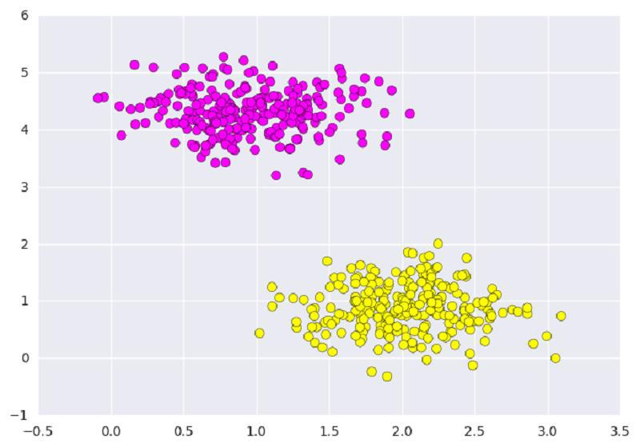

Fig Machine Learning Algorithm (SVM)

Here I have two various data sets and my task is to discriminate a linear classifier between these two data sets, but we have so many possibilities that these data sets can be divided and it is a problem. So to solve that I have used one of the machine learning algorithm called support vector machines(SVM). It was part of implementing various machine learning algorithms.

## Sample 2:

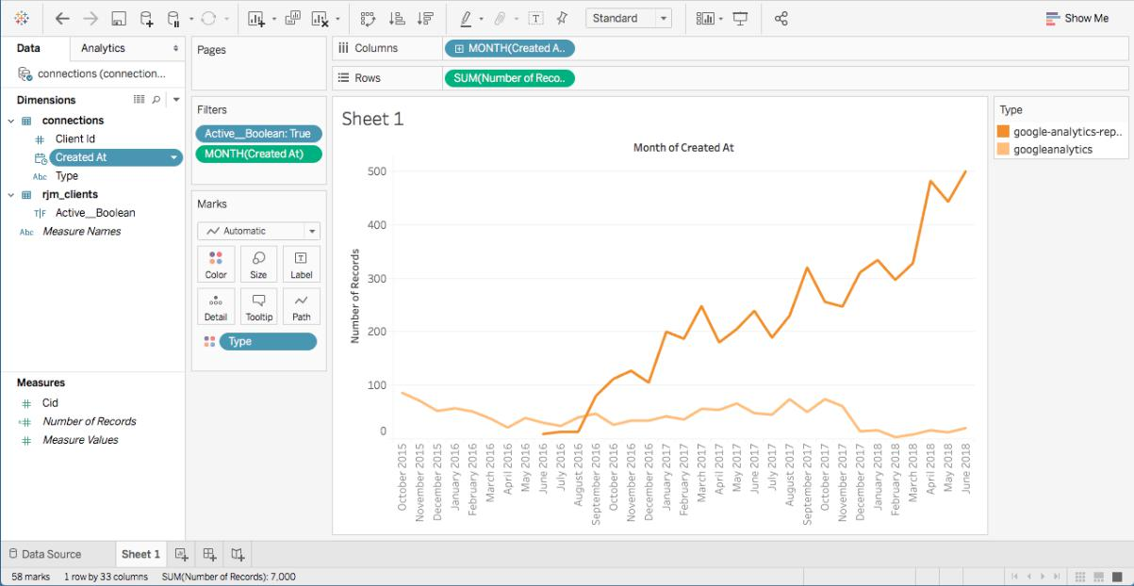

Fig 2 Visualization process using Tableau

Above shown in the picture is the visualization process of one of the company’s active google analytics clients versus actual active clients. This example shows the learning curve for me to observe different interface, learn about new techniques and how to efficiently visualize data so it does loose its original meaning.

## Sample 3:

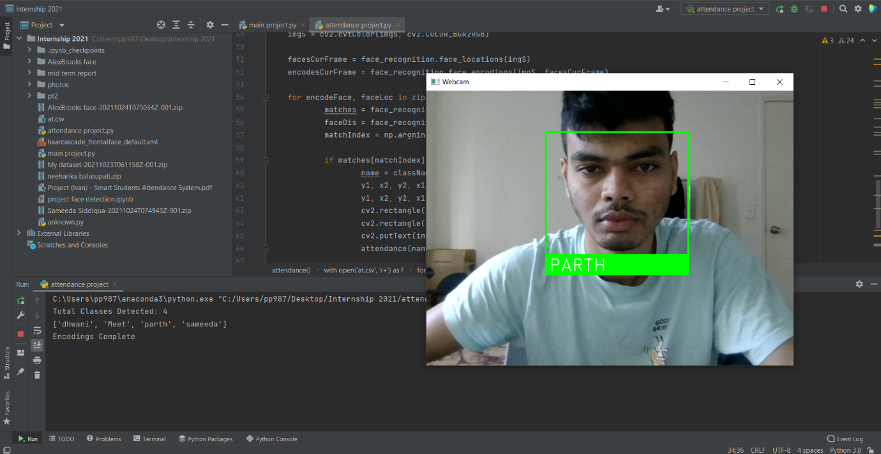

Fig 3 : Face detection and reading images using OpenCV

Work sample 3 defines the project’s beginning in which I have created a script to read a images using webcam and be able to successfully identify image using OpenCV library here in the images Is the example of it.

## Sample 4:

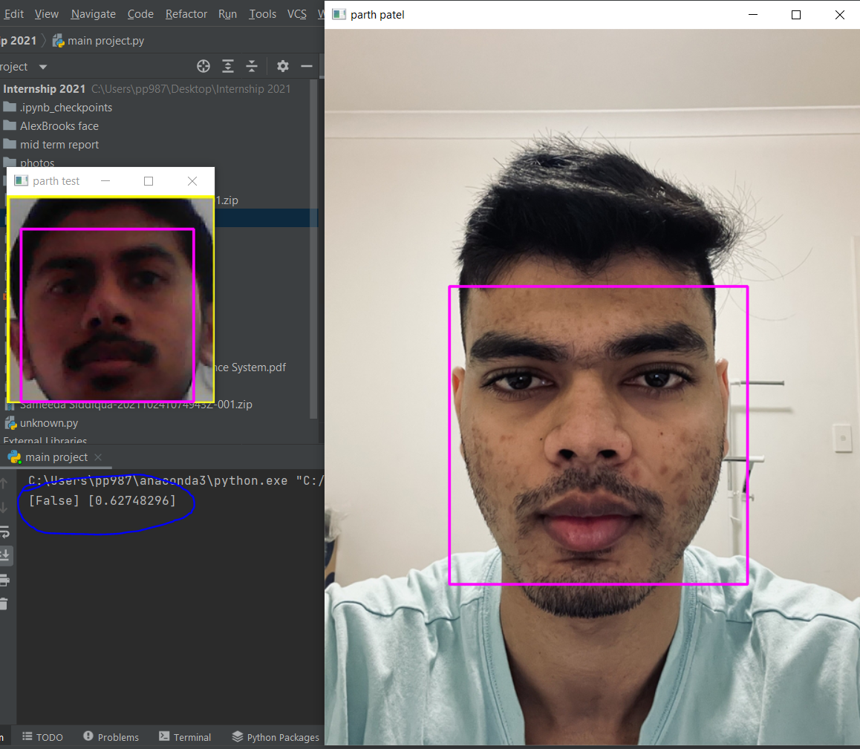

Fig 4: Comparing two faces to check the model accuracy.

In this work example I have tried to import two faces into the training dataset and had successfully compared it with live face detection using opencv library and it shows the results whether it matches or not, and you can see it bottom left blue circle which I have created to amplify the results which is false.

## Sample 5:

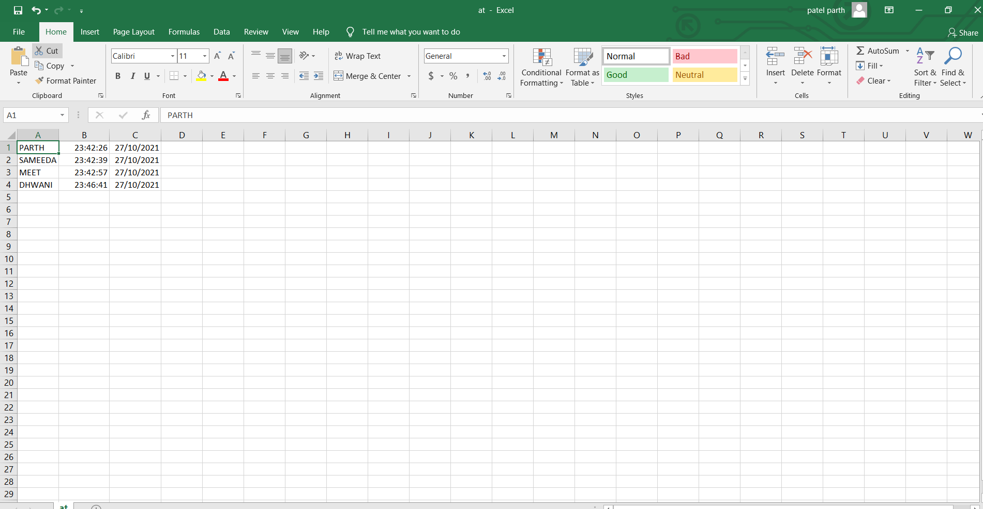

Fig 5: CSV file of student’s attendance

Above example shows the snippet of csv file which I have created in the model which basically identify student through the live feed of webcam and put all the information regarding that face in to the csv file with the person’s name and it puts the date and time of the attendance as well.

15

# Critical Analysis:

Analysis on my current internship has led me to many thoughts which I am about write it down here. The main about solving any problem which as a data science we often do cause we need to derive insights from the current data. So to identify and recognize the problem before hand a key solution. There are various paper available on how to deal with the problems I have started to read those and came to conclusion that there no one way to tackle all the problems

As an instance for my internship project states a whole new idea and a journey to embark on, so any old techniques or aid are not helpful in tackling those situations. So I have come with something new in order to increase my problem solving abilities and work efficieny. I have studied research papers, used an existing dataset but my task has its own new challenges and solutions. My project is about solution of student attendance system by recognizing their faces. So whole new dataset is being accumulated on my part which includes clarity, facial expression and size etc. all theses factors need to be considered in order to complete the project.

I am still working on accumulation process as of now I am reading papers regarding similar problems, algorithms and techniques they have used in order to fulfill the project need.

16

# SWOT Analysis:

**Strengths:**

ITIC is a global leadership IT oriented company with a highly experienced and respected in their fields CEO and executives, they highly goal oriented and career focused. Also, of the project which are currently running in the company are highly advanced and suitable to current need of technology. Provide a great environment to the clients and to their students which is highly sought in IT world.

**Weakness:**

Even though, company has a great deal of clients the number of employees are limited, and in still learning phase so they are not able to work at their full potential. What I have experienced in my internship learning phase is that interface of the site is not very pleasant and it still needed to be improved and need of highly professional materials.

**Opportunities:**

ITIC provides great range of products and services like cloud, networking, software etc. and also some of the best learning toolkits to advance in the field. And it becomes very useful in today’s world. ITIC also has a great amount of partnering opportunities with other firms.

**Threats:**

There are few companies out their which can challenge ITIC abilities in order to create more partnering opportunities and project. Some of the companies have highly talented people at their scrape. Also if all the projects are starts simultaneously at the firm it is hard to cope with the project deadlines.

17

# Conclusion:

In the end i will add that this internship opportunity provided me with a great deal of knowledge and skill to be better and to excel in my field, I love computer science and would like to expand my knowledge and skill in this field to be a better person. Also it taught me the importance of time management, professionalism and sheer focus on the tasks. It is not just my first internship but it Is a pathway to create my future and be better

This first six week has been extraordinary to me and I would like to show my gratitude towards all the people who I have been fortunate to in contact with. To be able to gain problem solving ability and mindset has prepared me a for a better future. The project journey for me has just began I extremely and excited to welcome upcoming next 6 weeks as I work on my project.

ITIC has me provided with a great skill and tools which are required in today’s technical world, it has also taught me the importance of leadership and to also be a team member. To put my ideas forth and to listen to everyone else at the same time. ITIC has a potential to become one of the best IT firm in Australia and can expand to world wide in near future.

18

# Recommendation:

I do not have that many recommendation as of yet, but I will say this that please upgrade the user interface of the student portal and make the material and lecture videos easily available. My concern is especially for lecture videos I could not be able to put a fast forward If I just want to quickly scan the learning because the player was not able to do that. Also If its possible you can hire an extra employee just to solve our technical and knowledge problem. I know the faculty can not be able to answer student’s issue immediately sometimes and that can hinder a learning process.

19

# References and sources:

<https://www.iticlive.com/>

<https://www.zoominfo.com/c/itic-pty-ltd/51055222>

<https://au.linkedin.com/company/iticsydney>

Carter, R. A., Jr, Rice, M., Yang, S., & Jackson, H. A. (2020). Selfregulated learning in online learning environments: strategies for remote learning. Information and Learning Science, 121(5/6), 321– 329.

Moolayil, J. J. (2020, May 23). A layman's guide to deep convolutional Neural Networks. Medium. Retrieved October 15, 2021, from <https://towardsdatascience.com/a-laymans-guide-to-deep-convolutional-neural-networks-7e937628605f>.

* <https://docs.opencv.org/master/d9/df8/tutorial_root.html>